Menominee County Fair Egg Record Book
Please check age group of exhibitor:
_____ BEGINNER (8 – 11 YEARS)
_____ INTERMEDIATE (12 – 15 YEARS)
_____ ADVANCED (16 – 19 YEARS)
Official Fair Age ____ (Fair age is the exhibitors age on January 1 of the year of the fair)

Exhibitor Name: _______________________________________________
Address: _____________________________________________________
City, State, Zip: _______________________________________________
Birth Date: ______________________________
JUDGING RESULTS (OFFICE USE ONLY) RIBBON AWARD: 1 2 3
Club Name: ____________________________
Club Leader: ___________________________
Cell Phone Number ________________________

Market Poultry Egg Projects (Please check the project you intend to complete. One record book per project):
Brown Eggs ______
White Eggs: _________
Blue Green Eggs: _________

All Market Poultry Record Books are due by 12:00 P.M. Friday of the fair.
The record book needs to be completed by the exhibitor.
PLEASE TYPE, PRINT OR WRITE CLEARLY.

Menominee County Fair Market Egg Rules:
(Please see the complete list of Poultry Dept. Rules in the Menominee County Fair premium book)
- Each exhibit shall consist of one dozen chicken eggs of the same color & size.
- Exhibitors may enter a single exhibit in each of the three Poultry Market Egg Classes.
- Pre-entry fee is $2.00 per Poultry Egg Market Class.
M.C.F. Poultry Egg Record Book 1.

- Each exhibitor will be required to complete a Youth Poultry Market Egg Record Book for each entry in the poultry market egg classes.
- Completed Record books must be turned in by 12:00 P.M., Saturday of the fair.
- All Poultry Market Egg exhibitors will be required to participate in poultry showmanship.
Exhibitors will find the M.S.U. 4-H Poultry Fitting & Showmanship Member’s Guide pdf at:
https://www.canr.msu.edu/uploads/236/66874/4H1520_4-HPoultryFSMG.pdf
Please sign below to verify you have read and understand the above rules. Also note that any extra rules or rule changes will be provided to the exhibitor at the fair during check in. I understand that this is a completed Youth Poultry Market Record Book as required.
Youth Signature: __________________________________________________

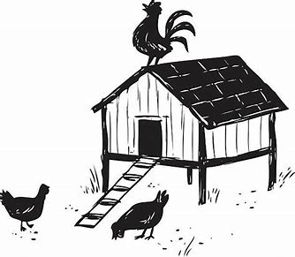
Parent/Guardian Signature: __________________________________________
Market Poultry Egg Project Photos
Be Creative! The more photographs the better! Your pictures should show the growth of your project from start to finish. Each picture needs to have a date, caption and be in chronological order. You may use additional pages.

M.C.F. Poultry Egg Record Book 2.

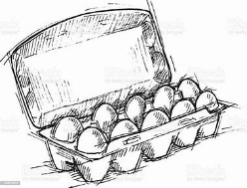
Poultry Egg Project Goals (at start of your project)

State at least two goals at the beginning of your project. Explain what you would like to learn.
1.____________________________________________________ _____________________________________________________
_____________________________________________________

2._________________________________________________________________________________________________________
_____________________________________________________

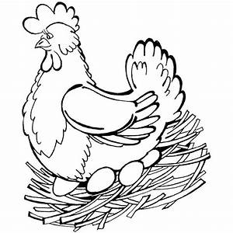
Poultry Project Accomplishments
(When project book is due)

What were the two most important things you learned about your Market Poultry Egg Project? What goals have you accomplished? If you have not accomplished one or more of your goals, please explain. What have you learned? Describe your experiences. (Attach an additional pages if needed.)
1._________________________________________________________________________________________________________
_____________________________________________________

2._________________________________________________________________________________________________________
_____________________________________________________

M.C.F. Poultry Egg Record Book 3.

All Egg Project Expenses
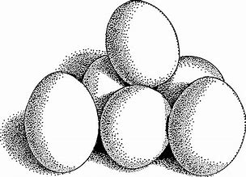
(Feed, Equipment, Medications, Vet Expenses, etc.)
Record of all cash expenses for your poultry egg project. Record the date, items (cost to purchase laying hens, feed for hens, vet/medical expenses, poultry equipment, egg cartons, etc.) and quantity as well as the cost. Also enter all non-cash expenses at their estimated value. (You may add extra sheets if necessary)

Date | Item | Quantity | Cost or Value

TOTAL $

M.C.F. Poultry Egg Record Book 4.
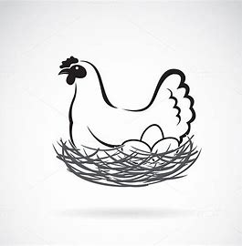
Poultry Egg Project Expense Record

All expenses reflected here occurred from:
Start date of project: _________________________
End date of project: __________________________

Total cost of hens used to lay eggs: $_____________________________________

Total cost of feed for laying hens: $______________________________________
Total amount of feed fed to hens during project: _____________________lbs.

Cost of all supplies & equipment other than feed: $_________________________

Vet care or general health expenses: $____________________________________

Mortality of laying hens lost during project (Expense Loss): -$_______________

Other Costs (Please specify): $__________________________________________
A. TOTAL POULTRY EGG PROJECT EXPENSES: $_________________

EXPECTED PROJECT INCOME: How much you expect to sell your dozen egg for at Menominee County Fair Auction: $________________________

Formula to calculate your Breakeven price:

$ ____________ _____________ = $ ___________________________
Total Poultry Egg One dozen eggs Breakeven price for one dozen eggs Project Expenses needed to cover expenses.
(Line A.)
M.C.F. Poultry Egg Record Book 5.
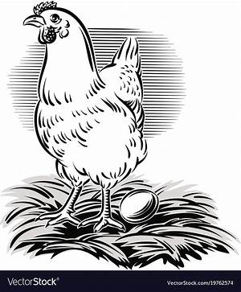

Your Market Egg Project Story

Tell your poultry egg project story through your own words. It should cover why you selected the particular breed of birds as layers. You should also describe your daily care and egg collecting routine. It should also list any problems, if any, you had with your project. For example, if there is a drop in egg laying, explain what you did to get your birds well. The project story should be a summary of what you have learned from your market egg project experience. (Additional pages may be added, if desired.)

___________________________________________________________________________________
___________________________________________________________________________________
___________________________________________________________________________________
___________________________________________________________________________________
___________________________________________________________________________________
___________________________________________________________________________________
General Poultry Management Questions
Briefly Explain:
- Can you list any Biosecurity practices that can help protect your laying hens from Avian Influenza or what is known as bird flu?

- What did you look for in putting your dozen eggs together?

M.C.F. Poultry Egg Record Book 6.

PAGE | M.C.F. Market Egg Judging Rubric | Possible Points | YOUR  POINTS
1 - 2 | Cover Sheet & Fair Rules | 5
 | All information is neat and complete
2 | Project Photos | 15
Includes photographs of project animal(s)
Captions included with pictures
3 | Project Goals & Accomplishments | 20
 | All information is neat and complete
4 | All Expenses | 15
 | All information is neat and complete
5 | Egg Project Expense Record | 15
 | All information is neat & complete for class
6 | Project Story | 20
 | Story written
6 | General Poultry Management Questions | 10
 | All questions answered
 | TOTAL POINTS  1^{ST:} 100 – 80; 2ND : 79 – 60; 3RD : 59 - 30 | 100
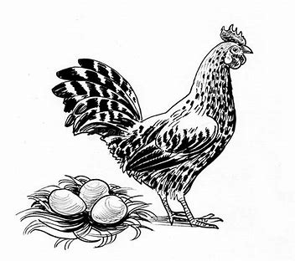
JUDGES COMMENTS

M.C.F. Poultry Egg Record Book 7.

